An Electronics for COLORES

Martin Kákona (MLAB) in August 2011

There are some simple electronics for COLORES (an astronomy spectrograph). It controls COLORES machinery and sends telemetry from the device. Because COLORES is a prototyping device the electronics is highly modular based on MLAB kit ([www.mlab.cz](http://www.mlab.cz)). This concept enables adding some new sensors or servos operatively due to project needs.

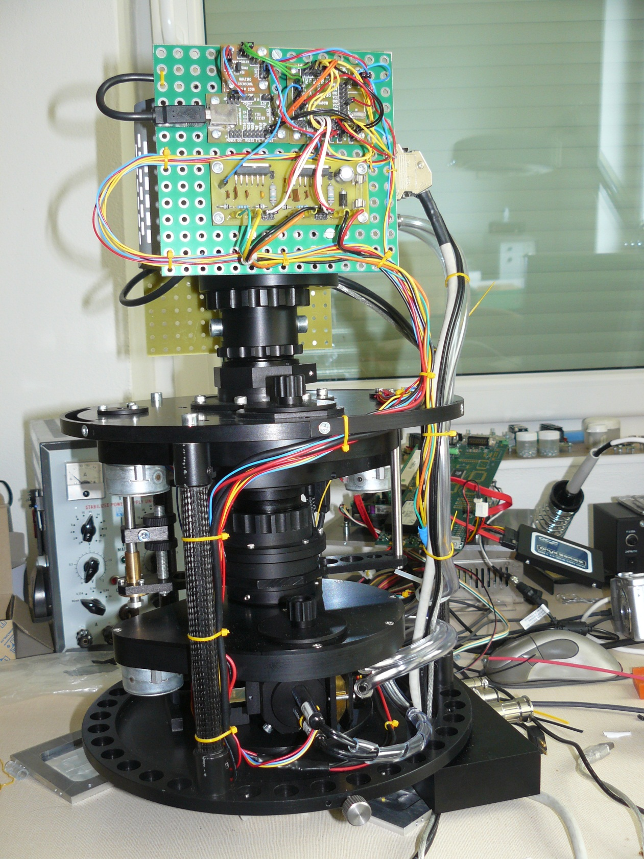

MLAB

Processor

Motor Driver

USB interface

Accelerometer

All electronics developed for COLORES is an Open Source Hardware with public documentation and it is possible freely remanufacture it or copy documentation only with mention about authors.

The electronics is driven by a board with a single chip microprocessor ATmega 328 [ 1 ] which is programmed for simplicity with Processing language [ 2 ]. Processing language allows modification of program by an inexperienced programmer without deep knowledge about electronics. The program can be modified remotely through Internet thanks bootloader which is preloaded inside processor.

The single chip processor communicates with a telescope control computer by an USB interface [ 3 ]. The telescope computer can send commands for changing a mechanical setup of device.   
A mechanical parts of COLORES are moved by bipolar stepper motor powered by H-bridge [ 7 ].   
The computer can read telemetry as well. The telemetry consists from information from light sensors [ 4 ], temperature sensors [ 5 ] and 3-axis accelerometer [ 6 ].

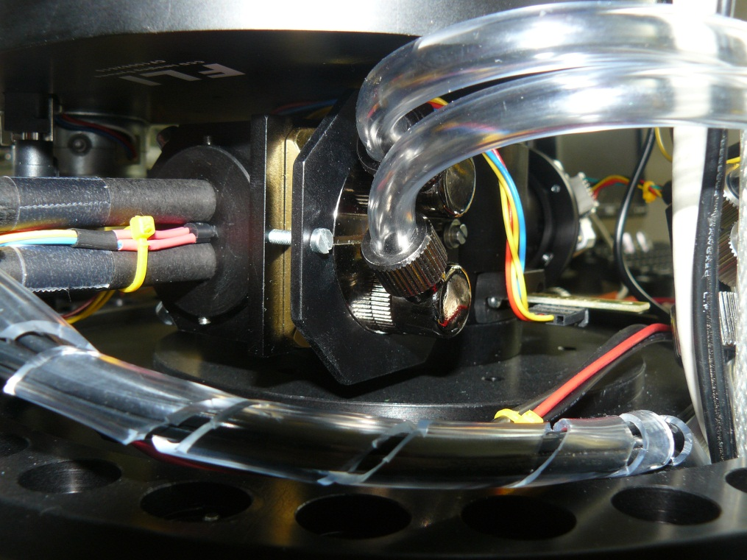

Thermometer

Light sensor

[ 1 ] Milan Horkel. <http://www.mlab.cz/WebSVN/filedetails.php?repname=MLAB&path=%2FModules%2FAVR%2FATmega801B%2FSCH%2FATMEGA801B_SCH.PDF>. MLAB 2005.

[ 2 ] Benjamin Fry, Casey Reas. <http://en.wikipedia.org/wiki/Processing_(programming_language)>. MIT 2001.

[ 3 ] Milan Horkel. <http://www.mlab.cz/WebSVN/filedetails.php?repname=MLAB&path=%2FModules%2FCommSerial%2FUSB232R01B%2FSCH%2FUSB232R01B_sch.pdf>. MLAB 2008.

[ 4 ] Miroslav Janás. <http://www.mlab.cz/WebSVN/filedetails.php?repname=MLAB&path=%2FModules%2FSensors%2FISL2902001A%2FSCH%2FISL29020.pdf>. MLAB 2011.

[ 5 ] Dallas semiconductor. <http://www.mlab.cz/WebSVN/filedetails.php?repname=MLAB&path=%2FDesigns%2FSpectrograph%2Fpdf%2FDS18B20.pdf>

[ 6 ] Jakub Kákona. <http://www.mlab.cz/WebSVN/filedetails.php?repname=MLAB&path=%2FModules%2FSensors%2FGSENSE01A%2FSCH%2FSCH.pdf> . UST, MLAB 2009.

[  ] Miroslav Seidenglanz. <http://www.mlab.cz/WebSVN/filedetails.php?repname=MLAB&path=%2FModules%2FH_Bridge%2FHBRIDGE02A%2FSCH%2FHBRIDGE02A_SCH.pdf>. MLAB 2007.